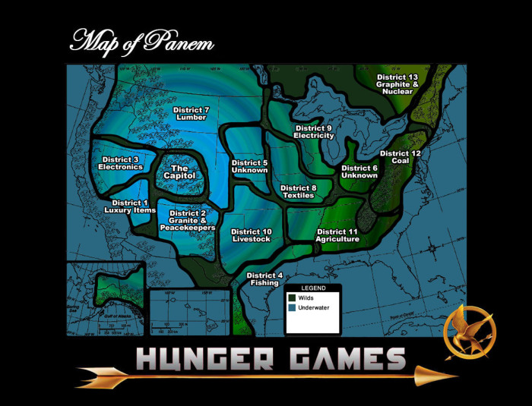



Literacy is key

ENGLISH

The Hunger Games Unit

As we start off our school year I would love for us to keep connected as your child delves into the eleventh grade English class. For our first unit of the course your child will be reading The Hunger Games by Suzanne Collins.
Lincoln North Star High School
Lincoln, Nebraska 68504
Phone Number- (XXX) XXX-XXXX
Tristen.sharp@huskers.unl.edu
Miss Tristen Sharp
To the Parents of ________
“Happy Hunger Games! And may the odds be ever in your favor.”



Communication

Notes, emails, etc.
EMAILS
Email is the easiest way for me to answer any questions you may have about your child’s schoolwork.
NOTES
Throughout the semester I will be sending home worksheets and notes with students that they will need to do with you.
*Please know that I understand that some of your schedules may not allow for this to happen every time. If for some reason you cannot sign or do the worksheet with your child please give me a call.
MEETINGS
Once a semester, outside of parent-teacher conferences I would like to schedule a time to meet with the students and their parents. This meeting will help everyone stay on the same page.
As we dive into the world of fiction I would like to let you know a little about the tools that are available to you. I have created a webpage that is strictly for The Hunger Games unit. This webpage can be found at www.teac441tsharp.weebly.com I created this webpage to be a tool that not only the students can utilize, but also you as parents. The website has an overview of the lesson plans for the unit, it is even broken down into daily plans.
There are many literacy tools that I will provide the students with in class that they should take home to use while they read. If the student for some reason does not have the tool it can be found on the webpage under the LITERACY INTEGRATION UNIT tab.
I cannot wait to start this beautiful literacy journey with you and your child. Please contact me if you have any further questions.
Hope to talk to you soon!

ENGLISH

As an educator I find it

very influential that you, as parents,

are involved and aware of what your student is doing in his/her class.

Keeping everyone in the loop

